**Dan Aschenbach, AGVP**

**Advisory**

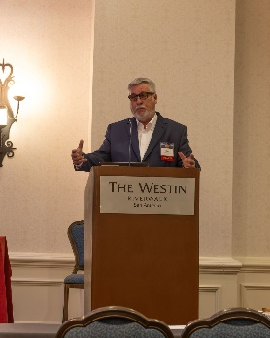

Dan formed a firm in 2019, AGVP Advisory at agvpadvisory.com. The firm has provided risk assessment consulting services for cities and electric utilities throughout the U.S.

Previously at Moody's Investors Service , Dan was senior vice president and led the firm’s Public Power Electric Utility Ratings team with a portfolio of $120 billion. Dan served on the Project Finance and Cooperatives Rating Team for more than a decade. Dan chaired the Rating Committees for most of his career at Moody’s. Awarded the top industry analyst award for Power for 15 years.

Prior to Moody’s Dan worked for US Congressman Tim Lee Carter and US Congresswoman Helen Meyner. Dan served on Cranford, New Jersey’s governing board for 18 years and 4 terms as Mayor.

.